- Purpose
  - The purpose of this document is to describe the procedure for assembling the Squeegee on a Genesys Scrubber
- Scope
  - This SOP applies to all equipment assembly team members. The process applies to the following machine ID’s:
EP50285EQS0600BE1200 – 30” Squeegee Assembly
EP50330EQS0600BE1200 – 35” Squeegee Assembly
EP50331EQS0600BE1200 – 40” Squeegee Assembly
EP50332EQS0600BE1200 – 45” Squeegee Assembly
- Responsibilities
  - The operations manager/supervisor is responsible for enforcing this SOP.
- Materials
  - The proper materials needed for this process are listed on the machine work order.
  - Drill Press with bit
- Definitions

- Procedure
  - Select the appropriate Squeegee Weldment. 30”-E28871 / 35”–E29552 / 40”–E28501 / 45”–E29551

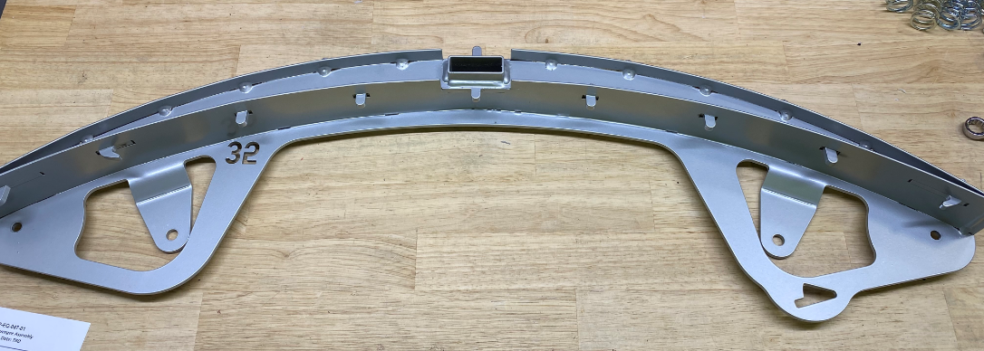

  - Place the appropriate front squeegee (has the gates) onto the weldment. 30”-E28872 / 35”-E29449 / 40”-E28504 / 45”-E29454
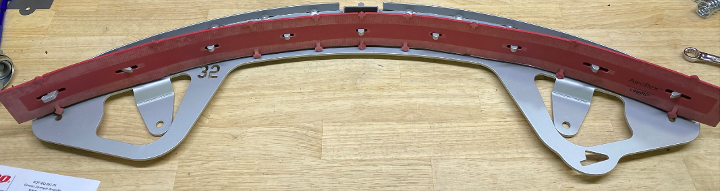
  - Take a front Squeegee clamp (wider band) assembly (30”-E28874 / 35”-E29451 / 40”-E29520 / 45”-E29456). Place a clamp (E29521) over the threaded studs in the orientation shown. Attach it with 2 lock washers (E28806) and 2 nuts (E29397). Note: This step may already be completed.
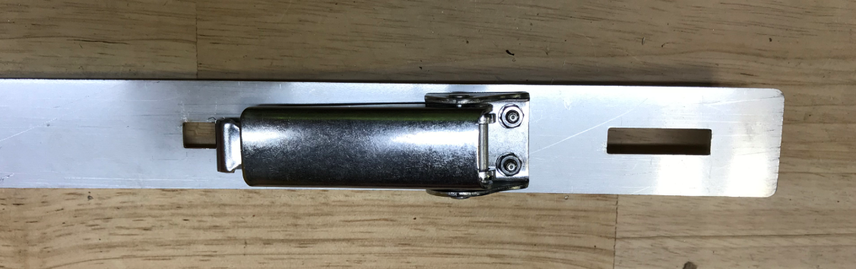
  - Place the assembly onto the weldment in the orientation shown. The clamp should be on the side of the squeegee with the squeegee length machined in. Adjust the length of the arm on the clamp, tighten the nut, and engage the clamp to hold the strap securely in place.
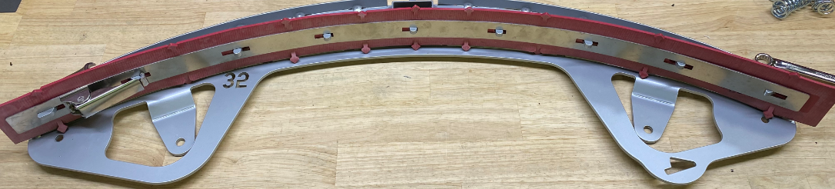
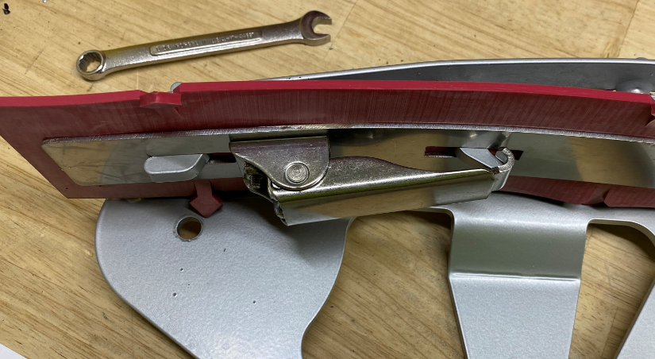
  - Place the appropriate rear squeegee (solid blade) onto the weldment. 30”-E28873 / 35”-E29450 / 40”-E28502 / 45”-E29455.
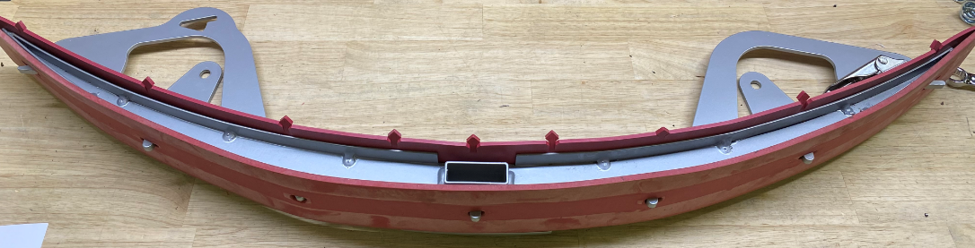
  - Take a rear Squeegee clamp (thinner band) assembly (30”-E28875 / 35”-E29452 / 40”-E29517 / 45”-E29457). Place a clamp (E29521) over the threaded studs in the orientation shown. Attach it with 2 lock washers (E28806) and 2 nuts (E29397). Note: This step may already be completed.
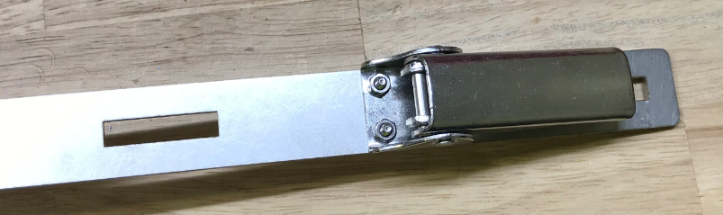
  - Place the assembly onto the weldment in the orientation shown. The clamp is on the opposite side of the squeegee as the first clamp. Adjust the length of the arm on the clamp, tighten the nut, and engage the clamp to hold the strap securely in place.
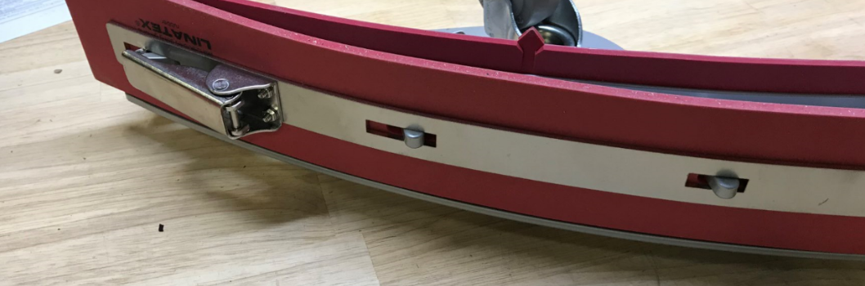

  - Attach two 3” bumper casters (EP50279 / Refer to SOP EQ 109) to the weldment using an oiled bushing (E28656), a flat washer (E28622) on top, a hex bolt (E29553), a flat washer (E28622) between the wheel and the weldment, and a nylock nut (E81063). Ensure the wheel spins. Repeat on the other side. Note the orientation of the wheel. The machined part is to face up.
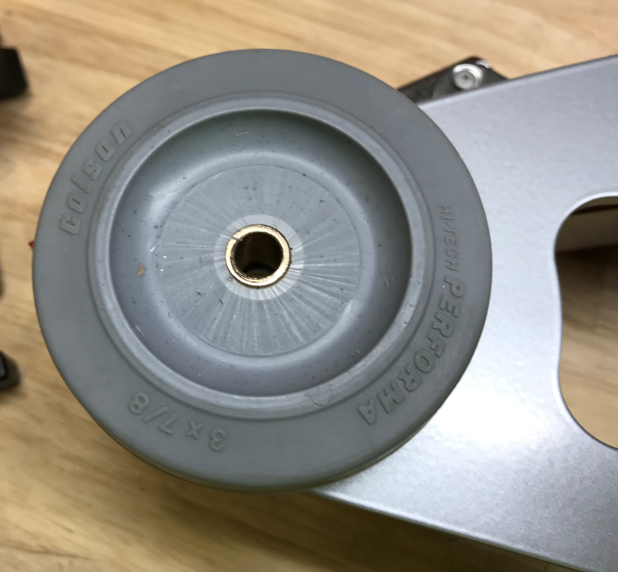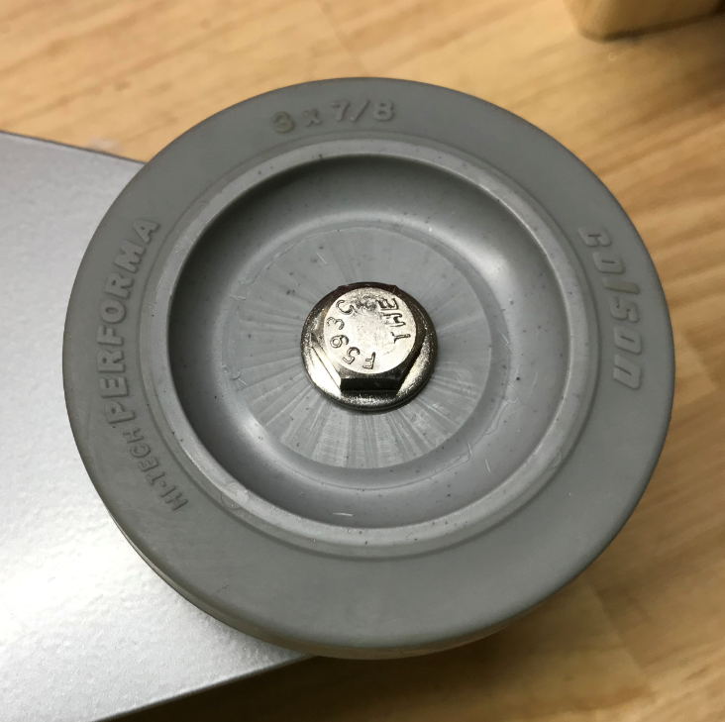
  - Prior to installation of squeegee drip tray run tap (1/4-20) to verify thumb screws will thread properly and are free from obstructions. Take a squeegee drip trap (E28908) and install an o-ring (E28754) into the groove. Attach the drip trap to the weldment using two thumb screws (E29554). Put some anti-seize compound on the threads of the thumb screws prior to installation. Note the orientation.
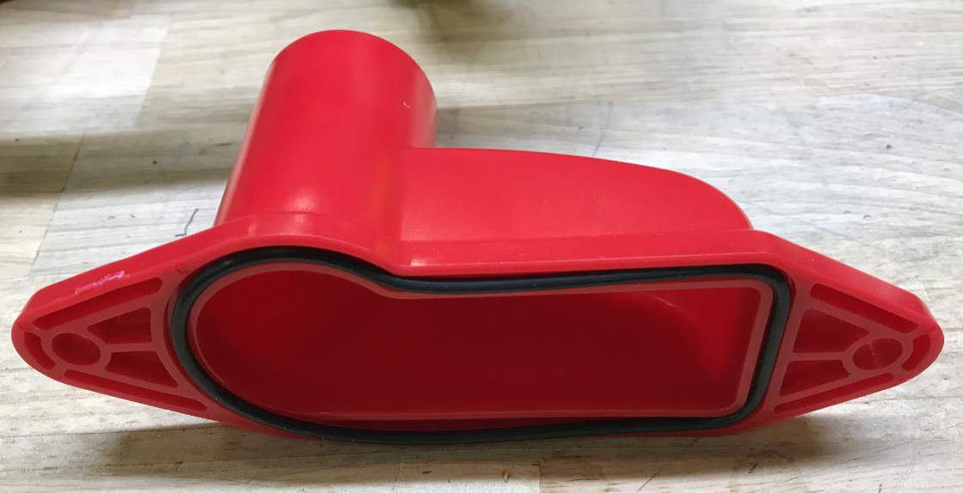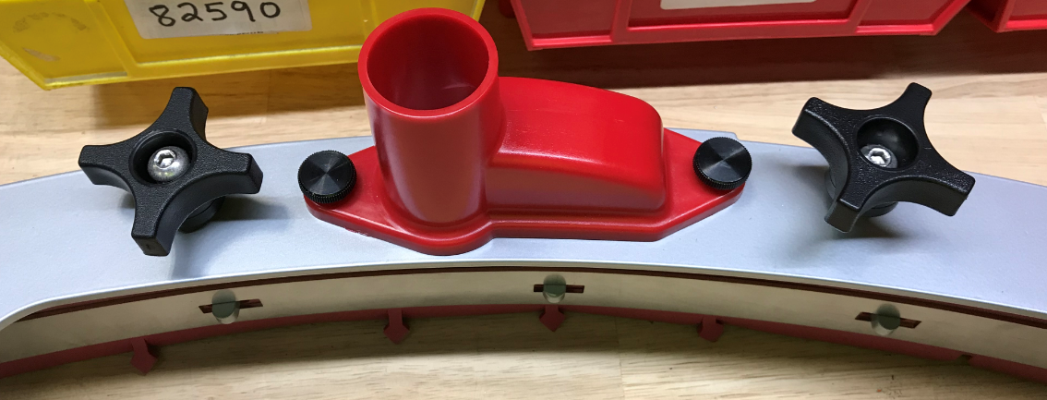

  - Take a knob (E28903) and thread a bolt (E29547) through it. Run tap (5/16-18) through to opening to verify the bolts thread properly. Then thread the bolt into the weldment until it bottoms out. Use the impact to do this. The knob should then thread up and down the bolt. Repeat for the 2nd knob. Verify the bolt is unable to unthread.
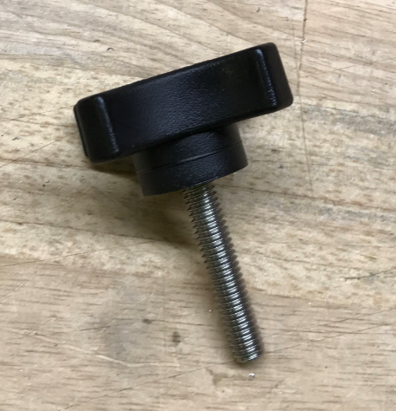
  - Attach the squeegee to the fixture shown using the two knobs. Ensure the squeegee is sitting up straight on the blades.
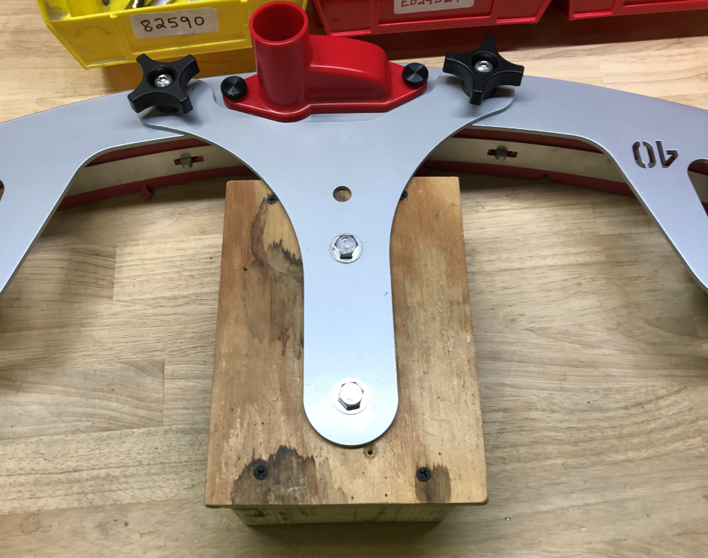
  - Take a swivel caster (E28568) and thread a nut (E29398) onto the stud. Place a serrated washer (E29050) over the stud.
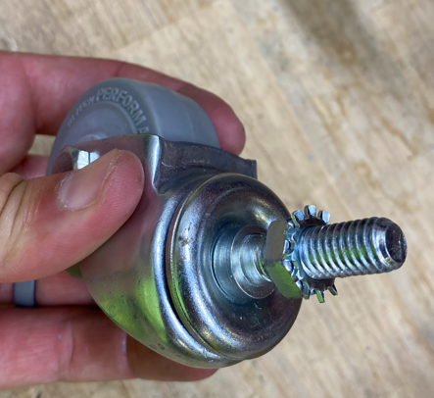
  - Feed the caster through the appropriate hole on the weldment. Put a 2nd serrated washer (E29050) and nut (E29398) onto the caster stud. Do not tighten them yet. Place the shim under the wheel and adjust the height of it. Lower the wheel until it just touches the plate then back it up about ¼ turn. Once the wheel is at the correct height, fully tighten the nuts with wrenches. Make sure the caster shaft does not spin while doing this.
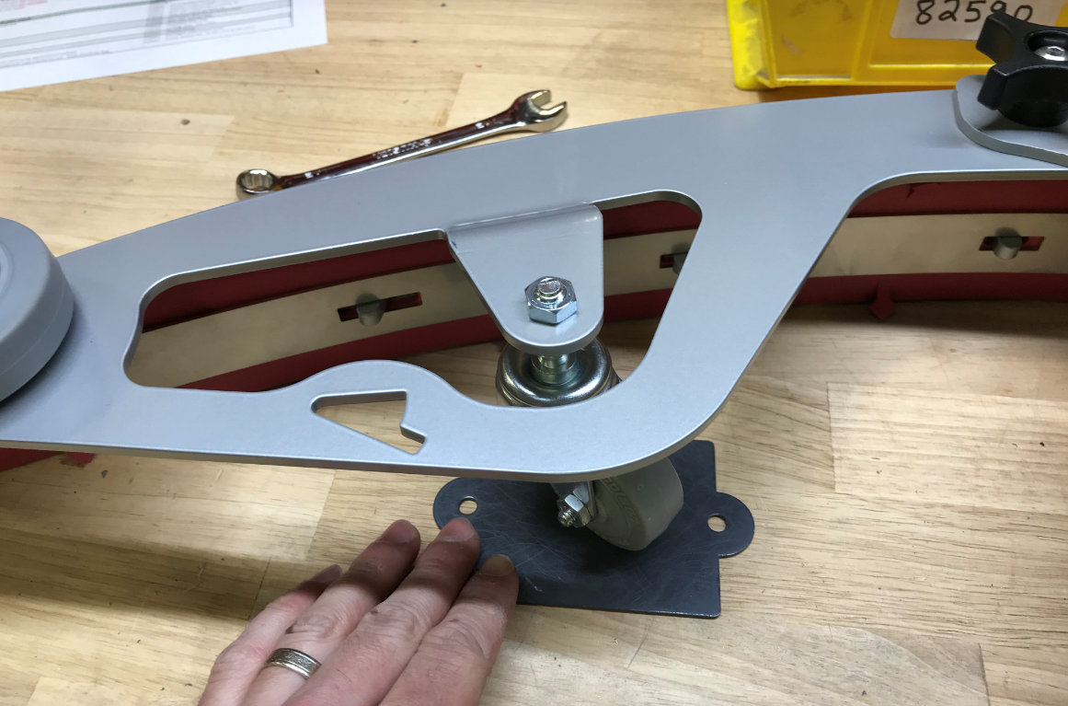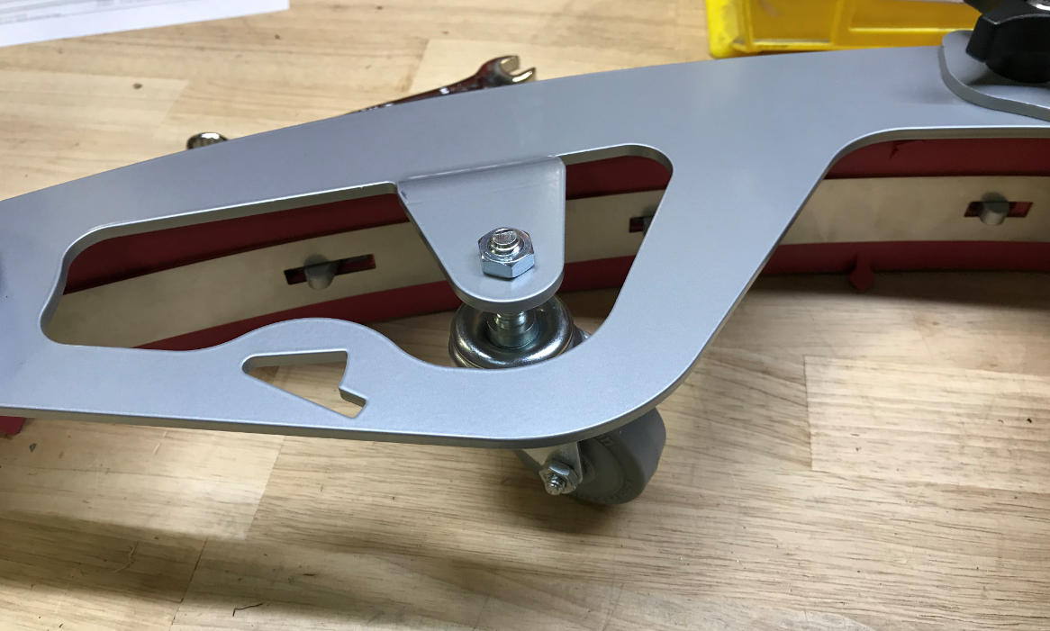
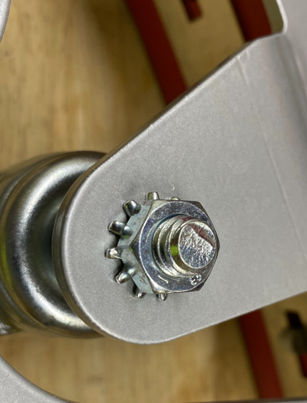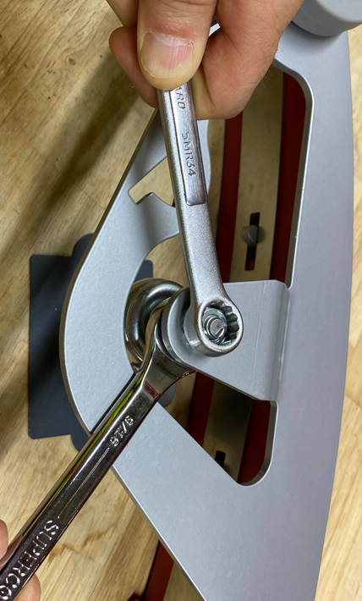
  - Once hand tightened, use an impact to complete the process. This will made sure the washers bite into the plate.
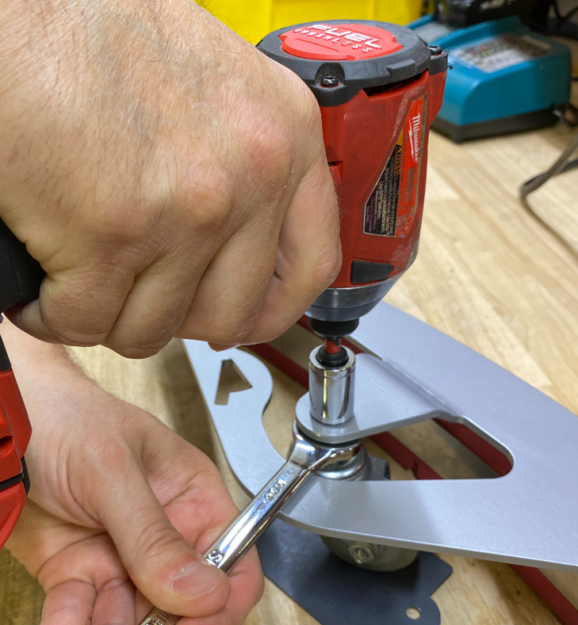
  - Repeat for the 2nd caster.
  - Place an acorn nut (E28851) onto the end of the caster wheel stud shown. It will be opposite the end of the squeegee with the cutout for the hanger.
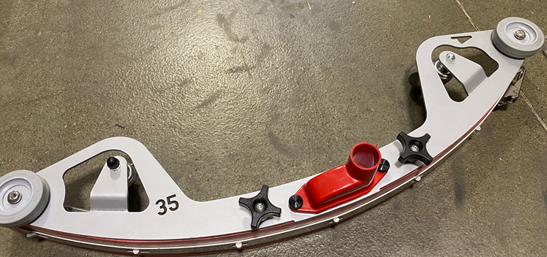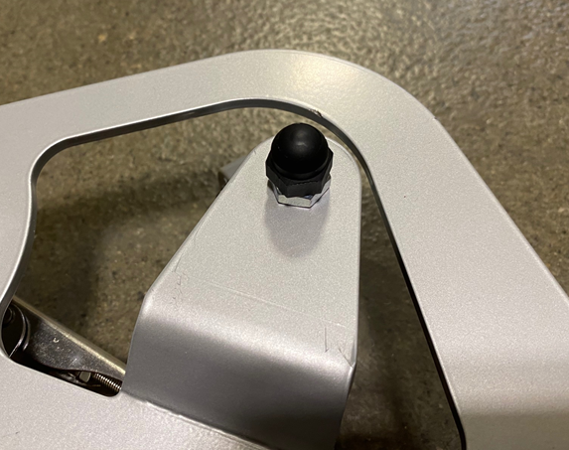

- References (optional section as needed)

- Training Guide

Functional Training Groups Requiring Training
Equipment Assembly Group

- SOP Change Control

Date of Change | Reason for Change
Rev 01 | This is the first version of the S.O.P. hence there are no revisions to this document.
Rev 02 - 8/13/2021 | Added QC Checks. Updated swivel caster installation instructions.
Rev 03 - 11/6/2023 | Updated to current process
Rev 04 - 3/31/2025 | Combined MSAS and G20 instructions
Rev 05 - 11/12/2025 | Updated mounting hardware for bumper wheels

Approvals

Submitter/Author Approval:__________________________________ Date:______________________

Management Approval:______________________________________ Date:______________________

QAU Approval:_____________________________________________ Date:______________________

